**CSC 212 Program 03 200 Points**

Develop a program to compare the performance of data retrieval for the following search methods:

* ***Sequential Search***
* ***Binary search of a sorted array***

Your program should have two classes, Project03 and Search as always required. Include two menus with your program interface:

* **File (About and Exit)**
* **Search (Open Files, Sequential Search, Binary Search)**

You will be provided with several datasets, Data Files (DataFile) containing unique integer numbers and Search Keys files (Keys) containing keys to search among data files.

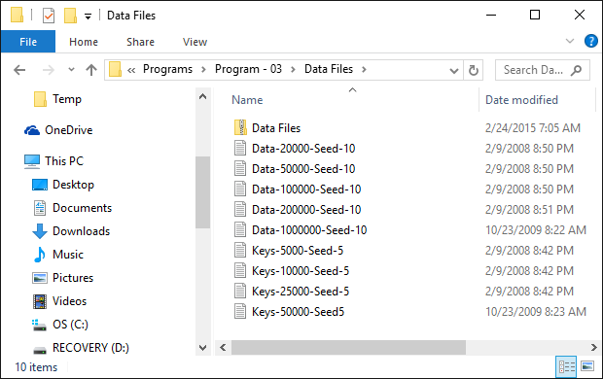

After opening the files selected by user inform the user whether the file access was successful or not.

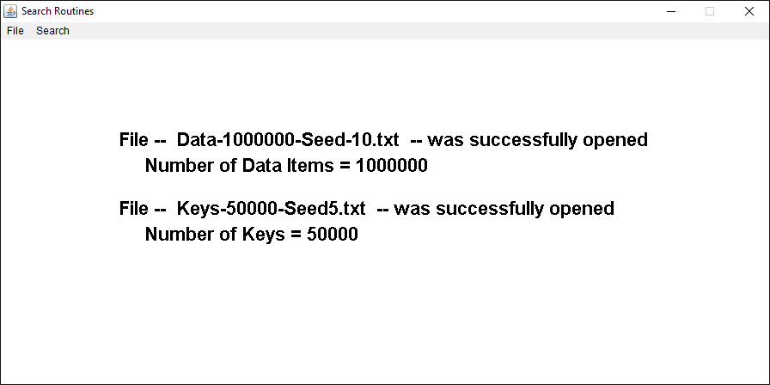

Use the data in Data File to create the original array. Create another sorted array (for binary search experiment).

Search for search keys in original array using ***Sequential Search*** and in sorted array using ***Binary Search.***

For each experiment measure the:

* **Average search time (measure the elapsed time for searching all keys then divide it by the number of search keys)**
* **Average number of comparisons (every time an “if” statement executes count it as one comparison) for successful and unsuccessful searches (use separate counters for number of keys found and not found and separate sum for the elapsed time).**

Report the same statistics for both search methods.

Display the results in tabular format with count of data items, number of search keys and number of successful and unsuccessful searches as title. Experiment title as row headings and average access time for each experiment and the number of keys and the average number of comparisons for successful and unsuccessful search as column titles.

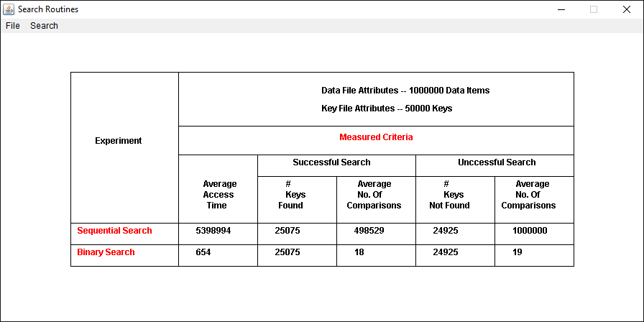

***Bonus (100 Points): Run two separate experiments, one for sequential Search another for binary search. Using the key set with 10000 keys, measure the elapsed time and number of comparisons for all given datasets and report them. Add a new Menu labeled Bonus with two options “Sequential Search Experiment” and “Binary Search Experiment” to report the results.***

***Bonus (100 Points): graph the results as a line or bar graph***

***Submit:***

* **Java files and the runnable jar file (make sure it runs) zipped into a file labeled as “your last name – your first name” through Black Board.**